Lab 5 – IAM

* Create a user with console access
* Attach policy for full admin access

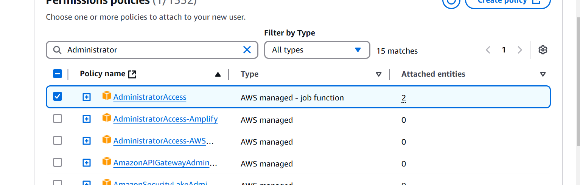

Go to user🡪Security Credentials

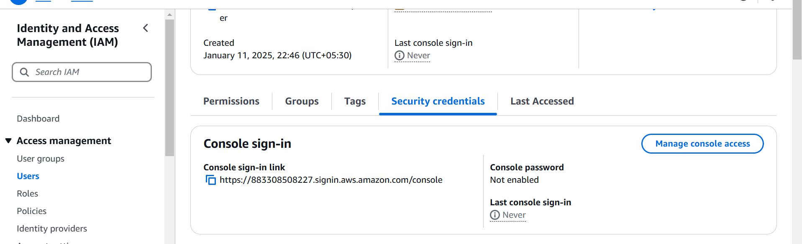

Click on Access keys

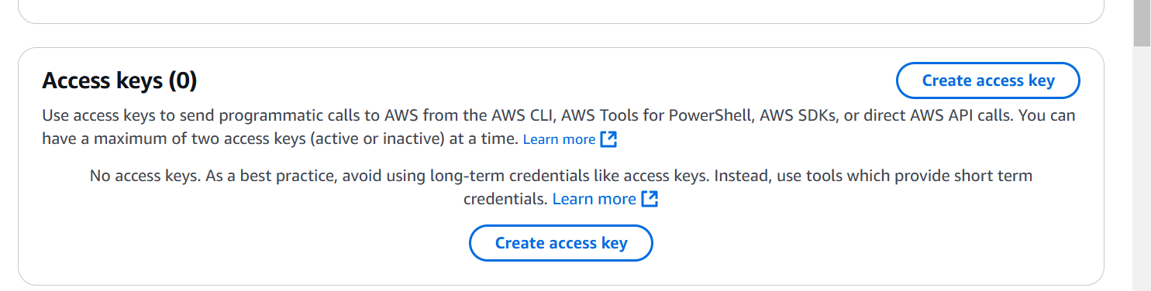

Select CLI options

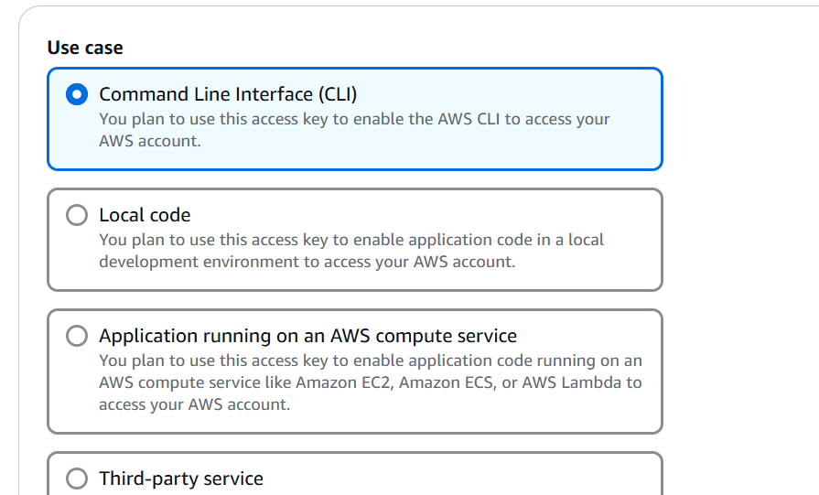

Create access key

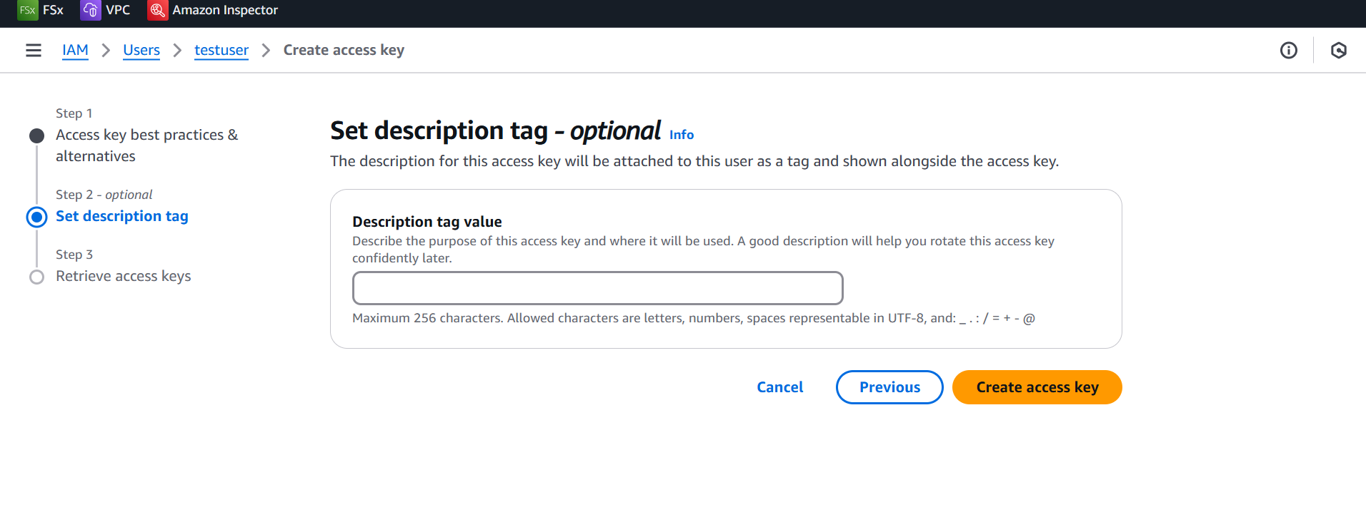

Download the csv

Install aws cli

<https://docs.aws.amazon.com/cli/latest/userguide/getting-started-install.html>

Download the msi

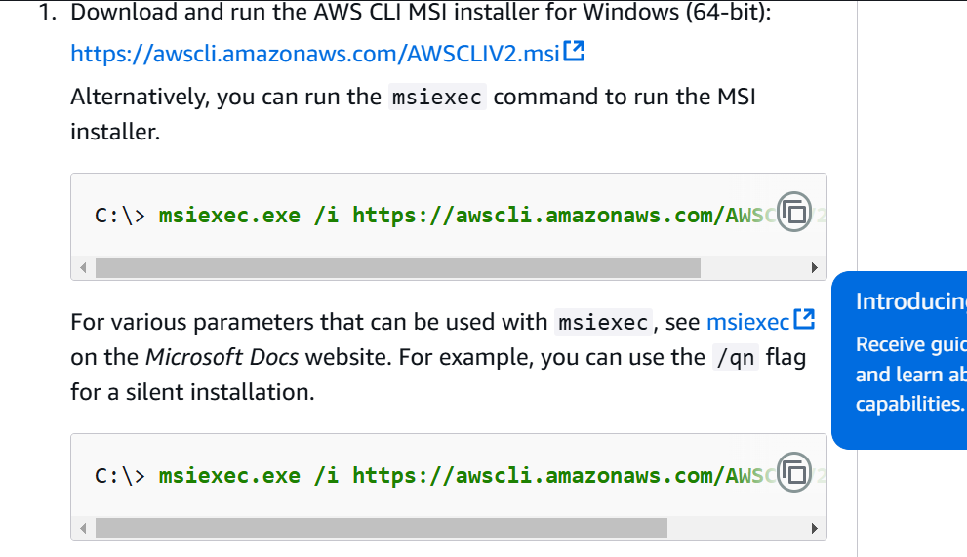

Install the msi🡪double click on msi🡪finish the installation

Open powershell and type aws

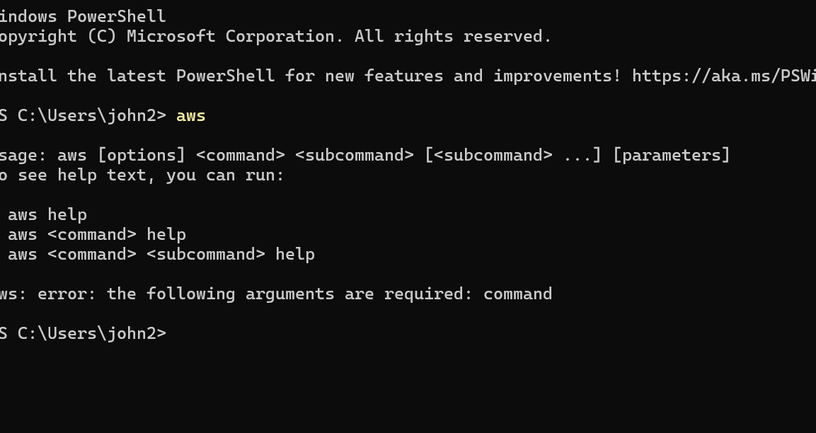

Run the command

aws configure

PS C:\Users\john2> aws configure

AWS Access Key ID [None]: (provide your access key)

AWS Secret Access Key [None]: (Provide your secret)

Default region name [None]: ap-south-1

Default output format [None]: text

Run the command to test

aws s3 ls